**Stage 4 – “Merry Christmas, shitter was full”**

**RULES:** USPSA Competition Rules, Latest Edition **COURSE DESIGNER:** John Royer

|  |  |
| --- | --- |
| **START POSITION: See written stage briefing.** | |
| **STAGE PROCEDURE**  See written stage briefing. | **SCORING**  **SCORING:** Comstock 31 rounds.  **TARGETS:** 15 cardboard targets and 1 steel target  **SCORED HITS:** 2 Best hits per carboard will be scored. Steel must fall to score.  **START-STOP:**  Audible - Last shot  **PENALTIES:** Per USPSA Competition Rules |

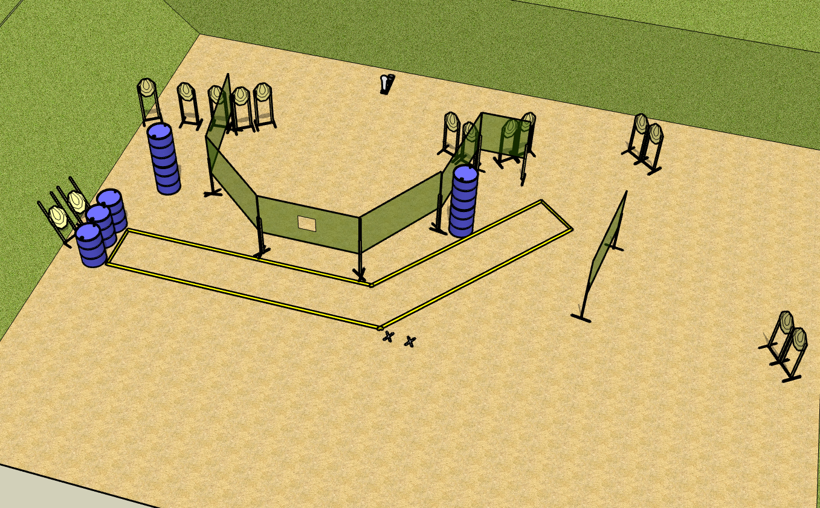

**Written Stage Briefing:**

**Stage 4 – “Merry Christmas, shitter was full” –** is a 31-round, 155 point, Comstock Long Course. There are 15 cardboard targets and 1 steel target. The best 2 hits per cardboard target will be scored. The steel must fall to score.

**Start position** Both feet on the Shooting Sports Innovation Xs, facing downrange.

Handgun: Loaded and holstered with wrists below belt.

PCC: Loaded, stock on belt.

On the audible start signal, “Get you sum”.

**Setup Notes:**

4 Single Wall Stands

5 Double Wall Stands

5 Full Walls

1 Half wall

1 Port wall

13 Target stands / 26 target sticks

2 45 degree target stands / 4 short target sticks

1 mini poppers and base

7+ barrels

1 Shooting Sports Innovations Xs